Customer Credit Risk Analytics
1. Project Overview
This project analysis customer credit risk using Nova Bank loan data from 32,581 customers. If Nova Bank approves too many high-risk loans, they will lose money. If they are too strict, they will miss out on potential customers. The goal is to find the right balance help the bank understand who is prone to defaulting, why they do so, and how to make lending decisions more reliable.
2. Dataset Summary
- Rows: 32,581
- Columns: 28
- Key Features:
- Customer demographics (Age, Gender, Home Ownership, Employment Length, Income, Marital Status, Education Level, Country, City, State, Employment Type)
- Loan details ( Intent, Amont, Grade, Interest Rate, Status, Credit History Length, History Default, Term, DTI, Past Delinquencies)
- Missing Data:
- 895 values in Employment Length column
- 3116 values in Interest Rate column
3. Exploratory Data Analysis using Python
- Import:

- Data Loading:
- Initial Exploration: Used df.info() to check structure, df.describe() for summary statistics and df.dtypes checking variables type.
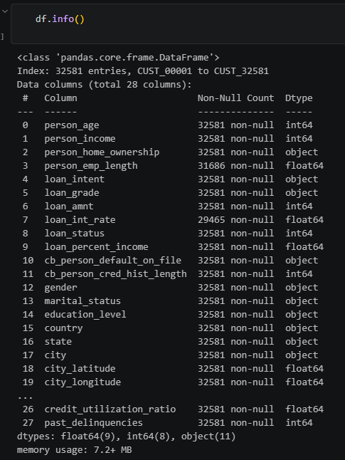
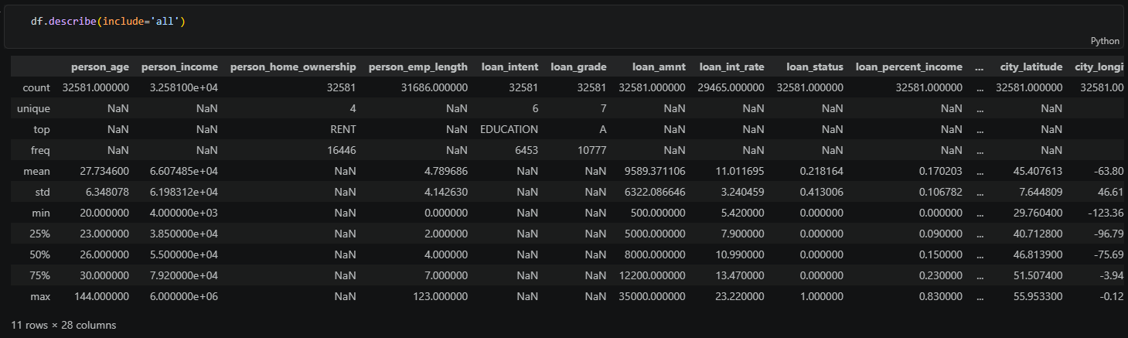
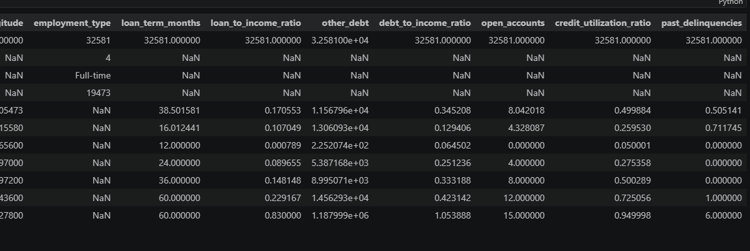
- Univariate Analysis: Using boxplot, histogram to check outlier, explore numeric and object variables distribution
- Multivariate Analysis: Used correlation charts to check the relationship between continuous variables. Check the relationship between variables and the target variable to see the impact and gain insights.
- Missing Data Handling: check for null values and fill missing values in the Employment Length column using the median value of the column, fill missing values in the Interest Rate column using the median value of each Loan Grade
- Data Consistency Check: We observed a strong correlation (=1) between the variable loan percent income and the variable loan to income ratio, dropped loan_to_income_ratio
- Database Integration: Connected Python script to SQL Server and loaded DataFrame into the database for SQL analysis
4. Data Analysis using SQL
We performed structured analysis in SQL Server to answer key questions and delve deeper into the interplay between variables
- Default Rate by Intent – Compared default rate by customer loan intent
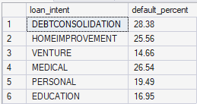
- Default Rate by Home Ownership and Employment type – Different default rate from type of job with home ownership
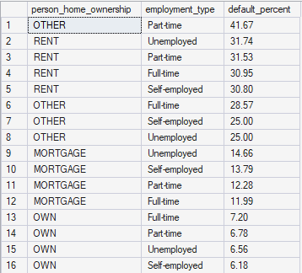
- Default Rate by DTI and Loan percent income – Impact from loan/income and DTI make default rate higher ?
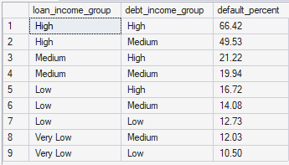
- Default Rate by Grade – Which grade has more risk
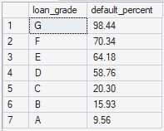
- Default Rate by Country – Which country has the most default rate, Are there any significant differences between borrowers in the US, UK, and Canada?
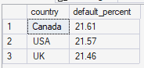
- Default Rate by Credit History Length – Impact from Credit History Length to Default Rate
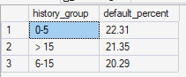
- Good Grade Default customer - How many customers are classified as loan categories A, B, or C (safe, low interest rates) but have a history of default? What is the actual default rate for this group?
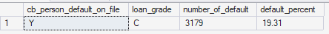
- Default Rate by DTI and Home Ownership - How does the combination of DTI and home ownership impact to loan default risk?
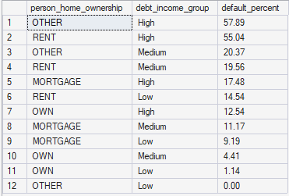
- Default Rate by Interest Rate and Grade - What is the average interest rate spread between defaulting and non-defaulting borrowers within the same Loan Grade?
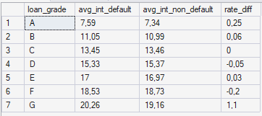
- Default Rate by Income and Loan - The impact of income and loan amount on the default rate.
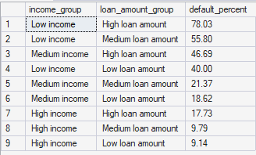
- Default Rate by DTI and Interest Rate - The impact of interest rates and DTI on default rates.
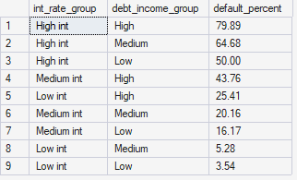
5. Dashboard in Tableu
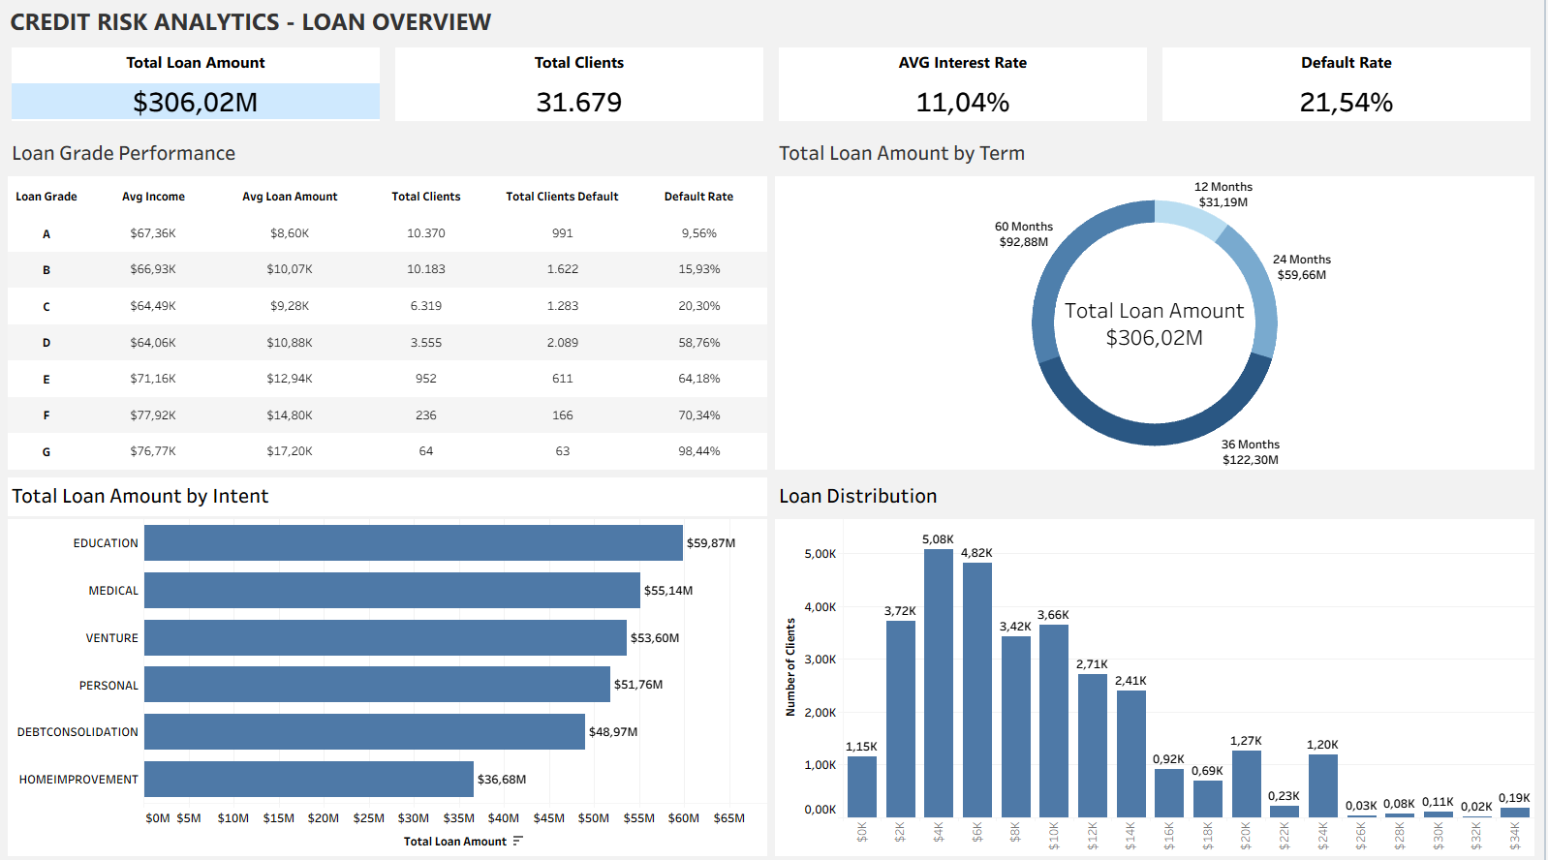
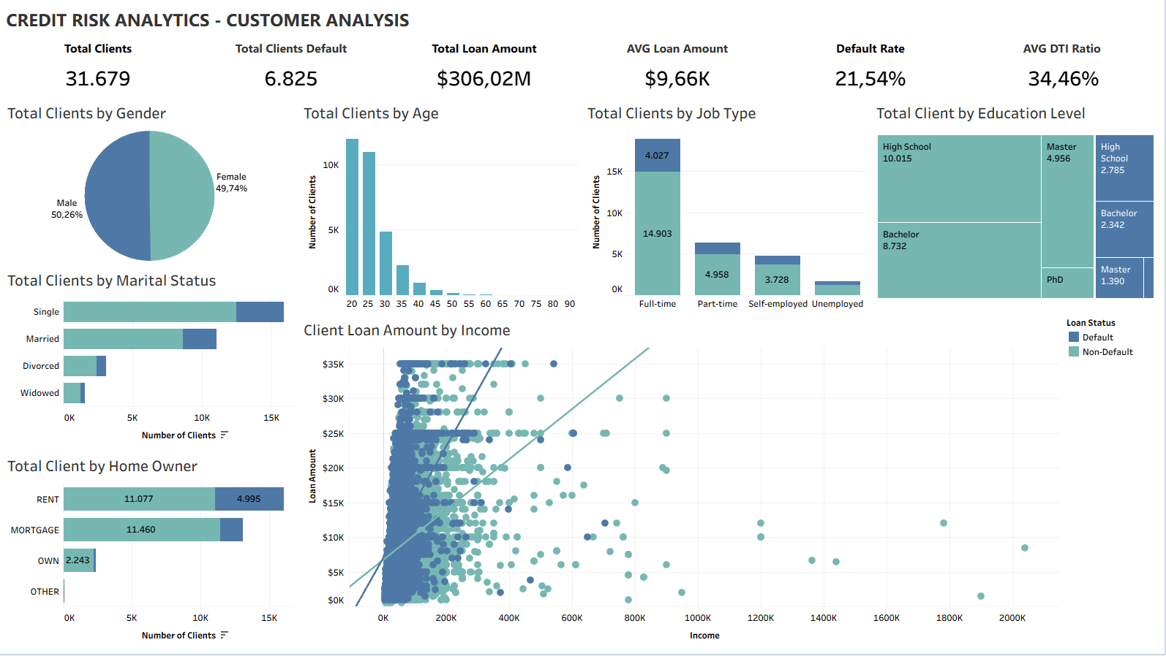
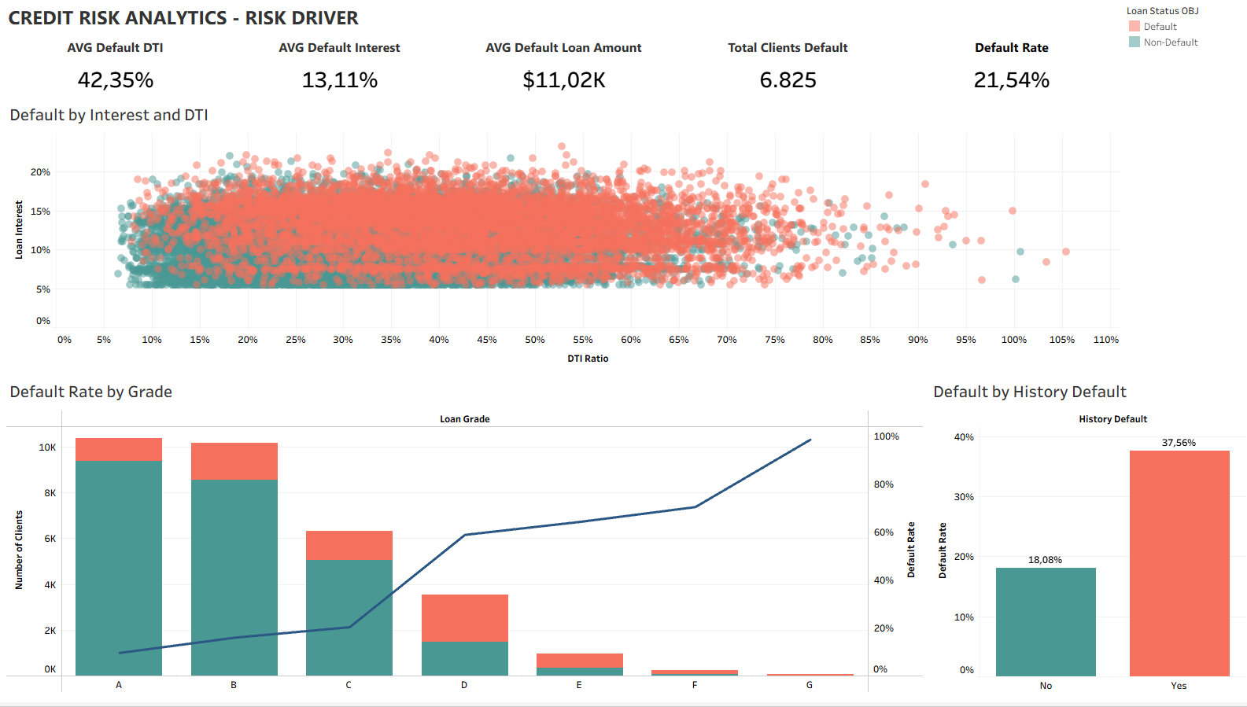
6. Business Recommendations
- Loan limits for low-income borrowers with high DTI - Reduce the risk of default for low-income earners.
- Add clauses or minimum requirements to the loan agreement - Minimize the risk of default from borrowing purposes.
- Implement stricter policies for borrowers in categories D to G - Remove high-risk default groups and require additional provisions to mitigate the default risk of medium-risk default groups.
- Prioritize terms related to home ownership or full-time employment - Reducing the risk of default when customers own a home or mortgage significantly improves the risk of default, and having a full-time job or being self-employed also results in a much lower likelihood of default.
- Pay attention to the history of defaults - Customers with a low default risk profile may still increase their likelihood of default if they have a history of default.
- Adjusting interest rates based on DTI - Higher interest rates and larger DTI lead to a higher risk of default. Instead of raising interest rates, it's better to refuse loans with a high risk of default.

